|  |  |  |  |
| --- | --- | --- | --- |
|  | King Fahd University of Petroleum and Minerals  Project Report  SARA ALBAJAD  JOUD ALSAYID |  |  |
| PROJECT REPORT | | | | |

|  |
| --- |
| Project Overview |
|  |

###### we solved the program using functions to implement each task separately. Functions help us divide our program into smaller, modular parts. And it helps our program become more orderly and manageable as it grows. It also avoids repetition and makes the code reusable.

|  |
| --- |
| main and its function |

The main function in Python acts as the point of execution defining the main function is a necessity to start the execution. It will provide the user with several choices to facilitate the process of booking, and it will keep running until the user exits with a specific option.

Code image:

|  |
| --- |
| menu and its function |

This function will Display the menu of the hotel booking system for the user.

Code image and output:

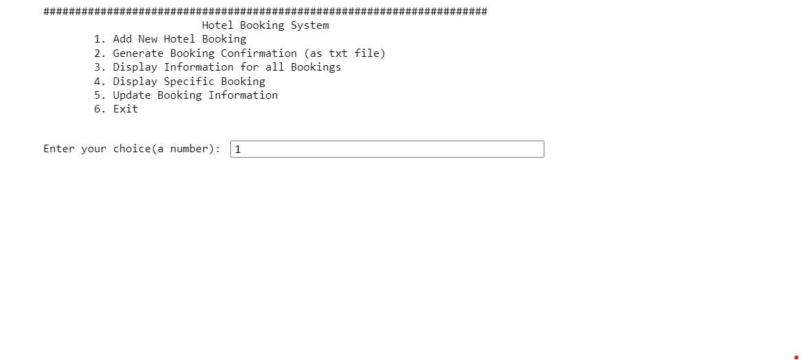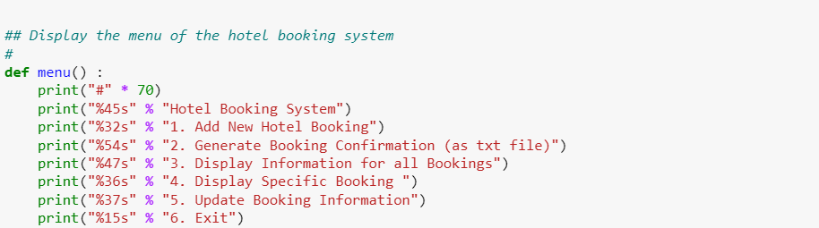

|  |
| --- |
| newhotelbooking and its function |

If the user has selected option 1, this function allows the user to add a new booking in the system. The program generates a booking confirmation number. The user's information is stored in the Bookings.txt file. The function return bookingData (dictionary) entered by the user. This data is stored in a dictionary only if it is valid.

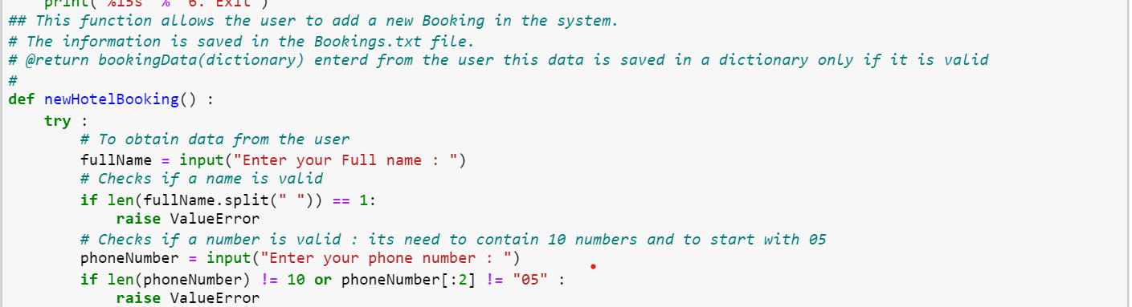Code image and output:

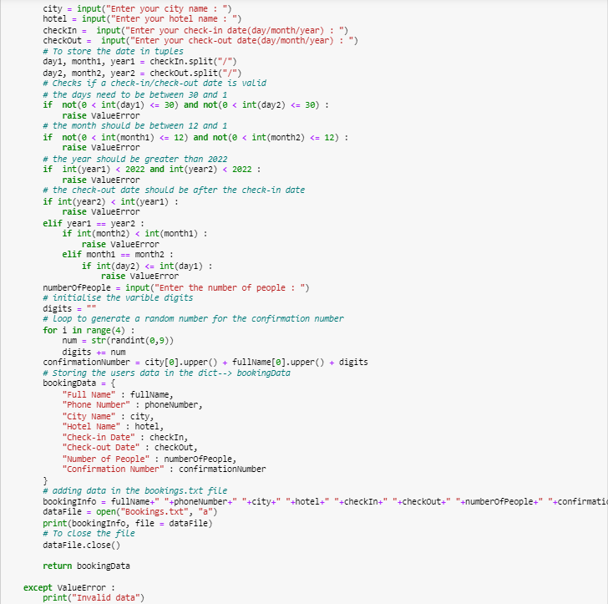

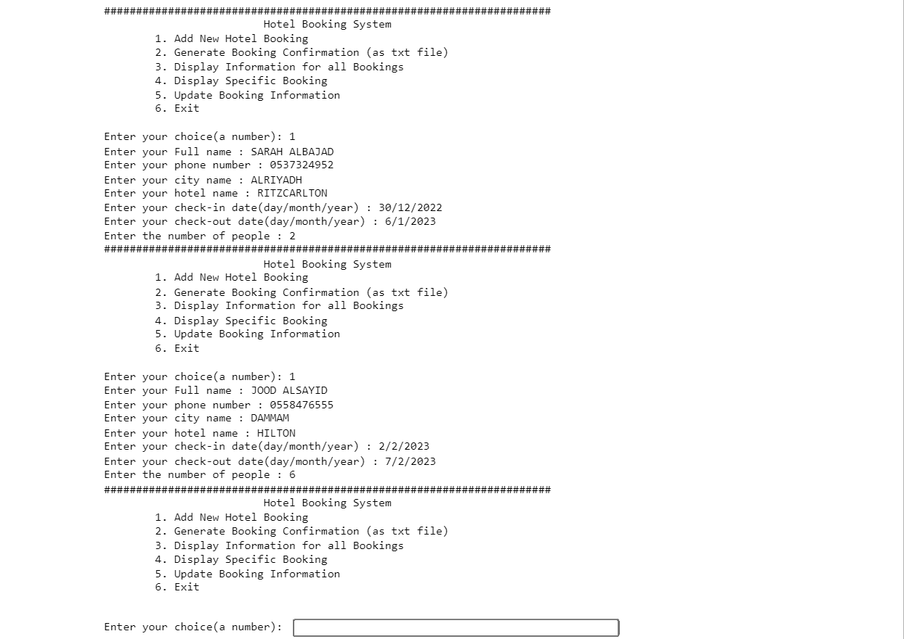

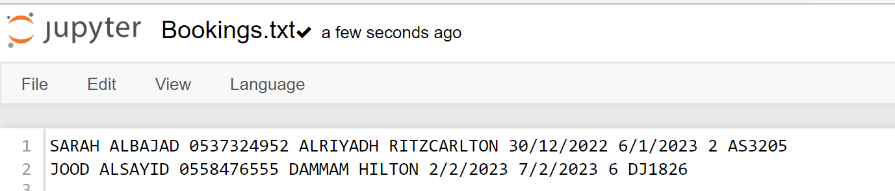

|  |
| --- |
| bookingconfirmation and its function |

If the user selects option 2, this option generates the confirmation as a file named "confirmation_lastname.txt". The argument is the data stored in the dictionary containing the user's last booking information

Code image and output:

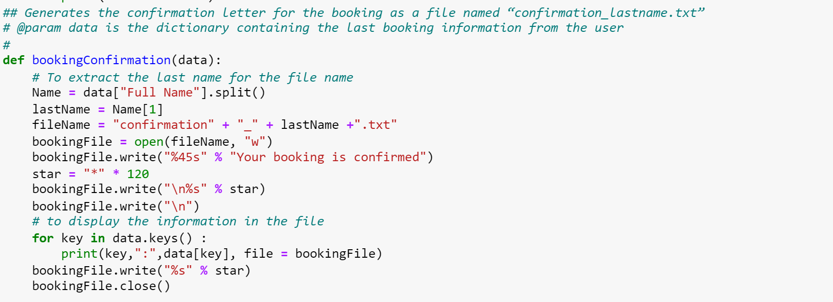

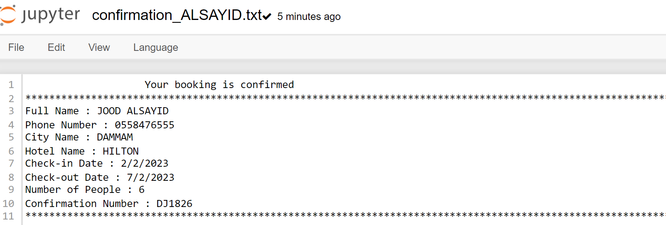

|  |
| --- |
| historyofbooking and its function |

If the user selects option 3, This function allows the user to display all the Hotel Booking’s information in a nicely formatted table.

Code image and output:

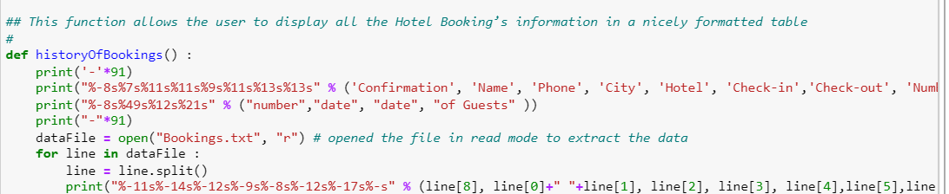

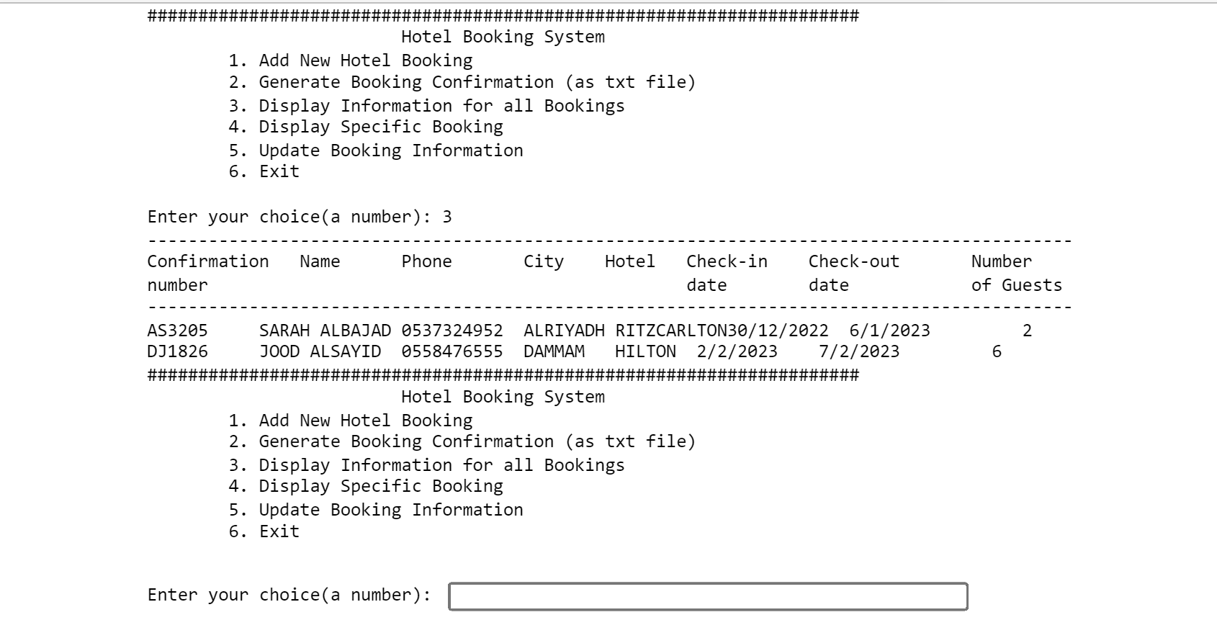

|  |
| --- |
| specificBooking and its function |

If the user selects option 4, This function allows the user to display a specific booking information based on Confirmation Number or Phone number. The argument is the user Input Confirmation Number or Phone number that was entered by the user.

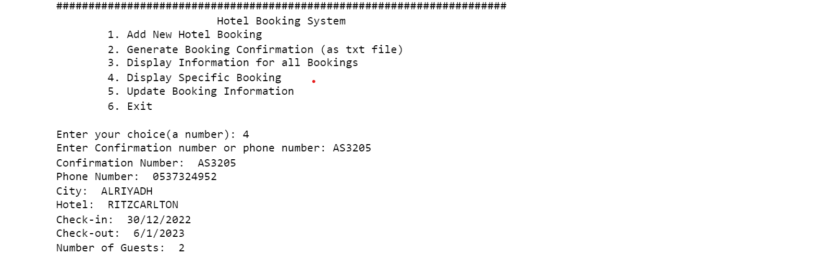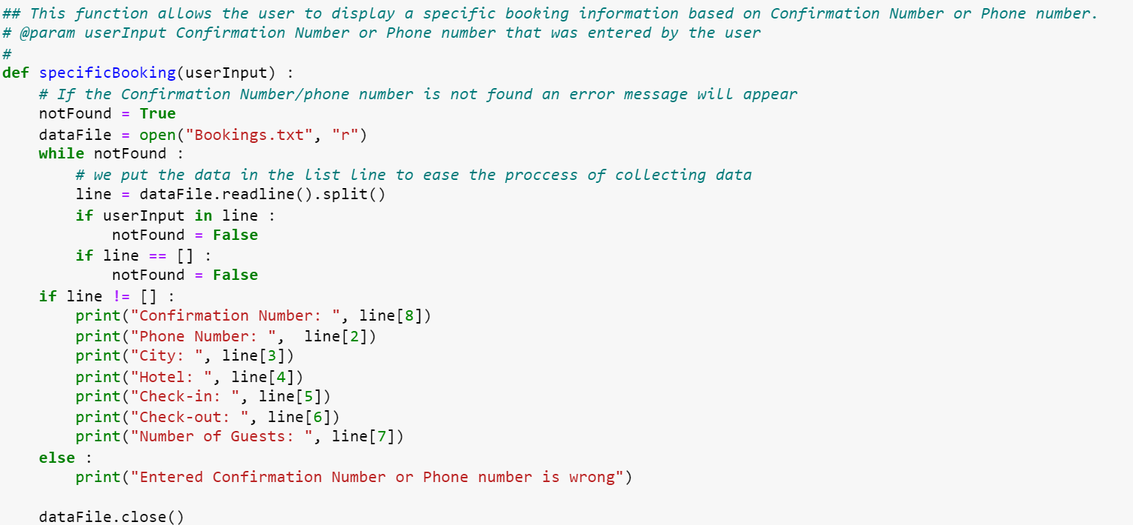Code image and output:

|  |
| --- |
| updatingbookingsmenu and its function |

If the user selects option 5, This function displays a menu to update Booking or cancel it or return to the main menu.

Code image and output:

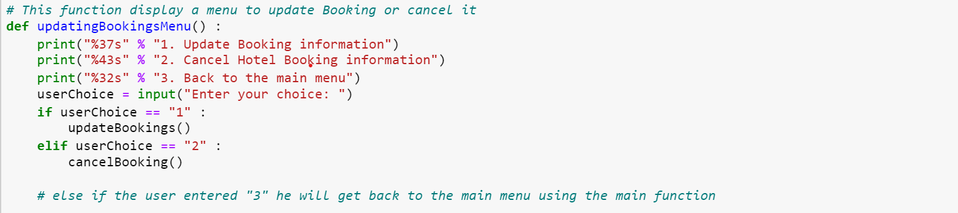



|  |
| --- |
| updatebookings and its function |

If the user selects option 5, then choose option 1, This function should allow the user to update hotel name and/or the hotel date using confirmation number.

Code image and output:

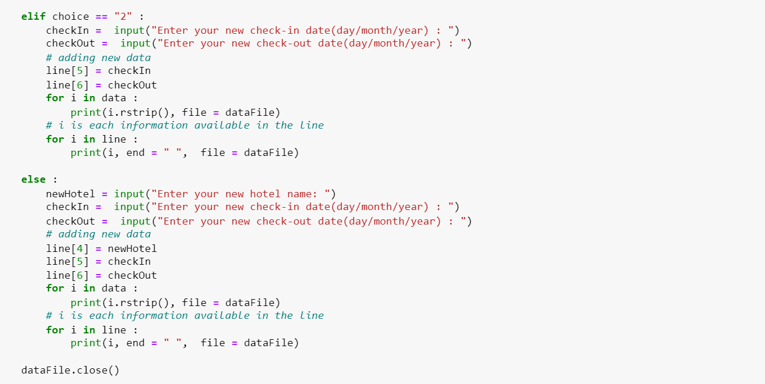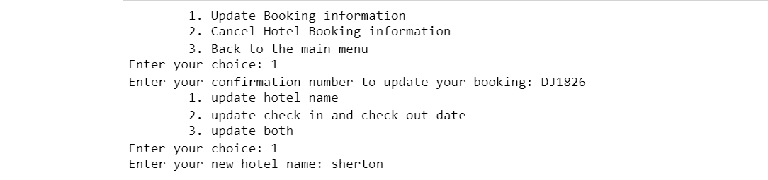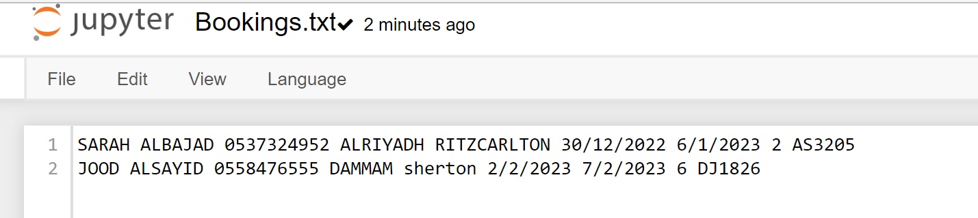

|  |
| --- |
| cancelbooking and its function |

If the user selects option 5, then choose option 2, This function should allow the user to delete booking information using confirmation number.

Code image and output: 